Musculoskeletal Disease-Related – Osteoporosis

Student's Name
Institutional Affiliation
Professor's Name
Course Name and Number
Assignment Due Date

Musculoskeletal Disease-Related – Osteoporosis
The anatomy, functions, and physiology of the Musculoskeletal System
The musculoskeletal system comprises the skeleton (bones), muscles, ligaments, cartilage, and tendons that form the body's framework (Hudson & Hamilto, 2017). The skeleton plays an essential role in the storage of phosphorus and calcium. When the concentration of these minerals is high, they are stored in the bones, but they are taken away from the bones in case the concentration is low. In addition, these minerals help in maintaining mineral balance in the blood system. Also, the hematopoietic system is contained in the skeleton in the long bones.
The hematopoietic system has red and yellow bone marrow. The red bone marrow is the site where the production of blood cells takes place. The blood cells produced in these sites are leukocytes, platelets, and erythrocytes, and they migrate to the circulation system (Hudson & Hamilto, 2017). The yellow muscles comprise fatty connective tissues and are located in the marrow cavity. In case of starvation, the body may use the fat in yellow marrow to produce energy.
There are different types of muscles. However, only skeletal and smooth muscles are part of the skeletal system. Skeletal muscles are attached to bones and play a significant role in movement. Smooth muscles have unique characteristics that move involuntarily under the impact of conscious control. Ligaments join the bones together to form a joint (Hudson & Hamilto, 2017). The ligaments are made with fibrous tissue, and their primary role is to prevent joint dislocation and prevent inappropriate hyperextension and hyperflexion. Ligaments are dense white bundles of fibrous elastic tissues. The joints are bone articulations that allow movements. Finally, the tendons are tough fibrous connective tissues that connect muscles with bones.

An image showing the anatomy of the musculoskeletal system
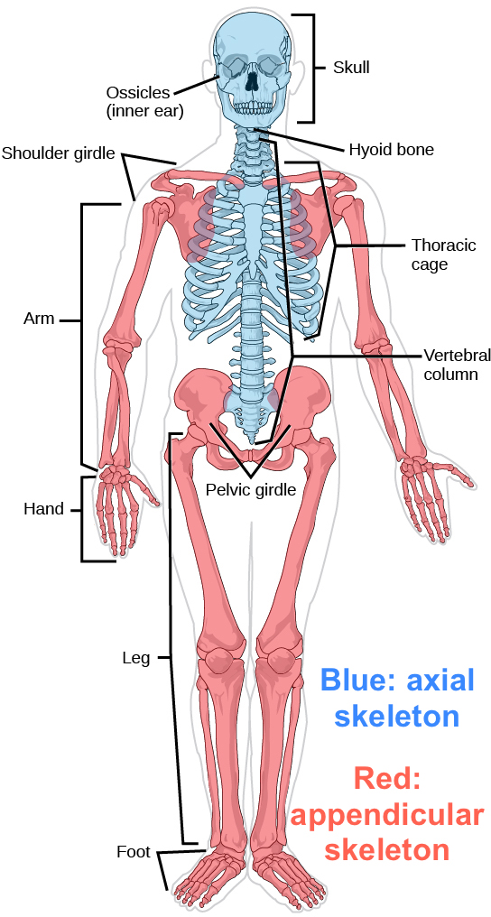

The pathology and Assessment of Osteoporosis
Osteoporosis is a metabolic bone disorder that causes skeletal fragility and is characterized by reducing bone mass and reducing bone tissues, which increases the risk of fracture. As a result, the condition has become a significant public health concern (Akkawi & Zmerly, 2018). The disease is caused by reduced estrogen levels that cause bones to turnover, and resorption is higher than bone formation. Estrogen hormone plays a significant role in helping to build and maintain healthy bones (Yu & Wang, 2016). However, in women, estrogen levels drop as they reach menopause. Also, the condition is caused by corticosteroids that affect the bones, resulting from unpredicted osteoblastic.
The condition can affect both males and females of all races, and it is age-related. The disorder affects the hip, spine, or wrist mostly, even though other bones can be affected (Watts, 2018). Bone tissues are broken down, but they get replaced constantly. If the replacement does not take place and the old bones are not replaced. Some of the risk factors that can result in Osteoporosis are: if a family has a history of Osteoporosis may increase the chances of an individual suffering from the disease. In addition, nutrition factor increases Osteoporosis risk, due to lack of some minerals such as calcium and phosphorus in the diet. Other risk factors include eating disorders, petite body frame, female, aging, renal disease, and smoking (Boros & Freemont, 2017).
Osteoporosis can be assessed through physical examination, laboratory tests, and bone density tests (Kuo & Chen, 2017). Bones that are assessed are the spine, wrists, and hip bones. The physical examination may involve a thorough assessment of the pelvic among women and check for bone fractures. Laboratory tests include conducting chemical analysis of serum when the history predicts conditions affecting bone density (Kuo & Chen, 2017). For example, a doctor may recommend a bone density test when the patient loses height, has fractured bone, has taken certain drugs, or in case the hormonal levels are low.
An image showing an X-ray of Osteoporosis
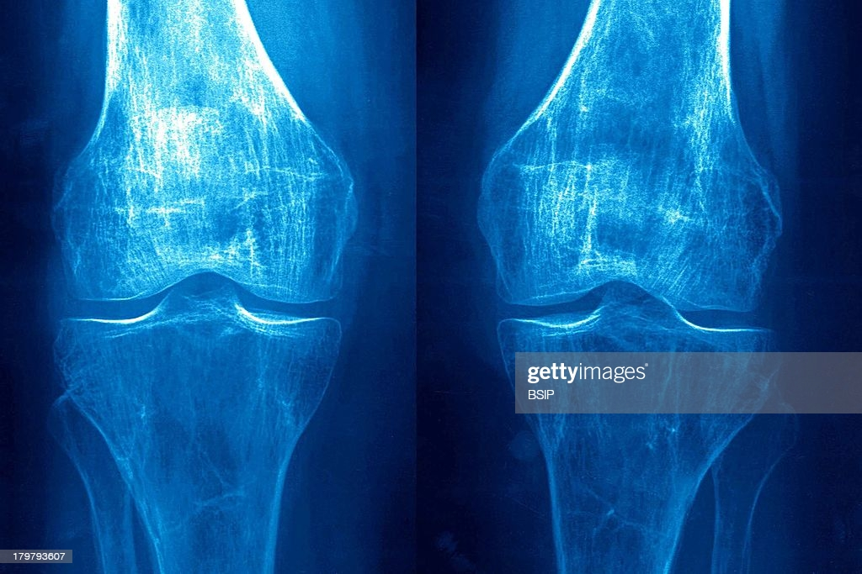

Signs and symptoms, a diagnostic test of Osteoporosis
In the early stages of Osteoporosis, there are no signs and symptoms. However, once the bones get weak by the disorder, the individual may experience the following signs and symptoms: loss of height over time, bones break than expected, back pain that is caused by fracture or collapsed vertebra, shortness of breath that results, and change in posture (Watts, 2018). Getting shorter with one inch or more may indicate the presence of this disorder. An individual stance might change, and the stance is stooped or appears to bend forward. Shortness of breath may be caused by the reduction of lung capacity due to compression of disks. The weakness of the bones causes a bone fracture, which may cause pain in the lower back.
The primary diagnostic test for Osteoporosis is bone density tests. The tests are commonly known as dual-energy X-ray absorptiometry scans (Kuo & Chen, 2017). These tests only use a limited amount of radiation to determine bone density, risk of fracture, confirm a diagnosis of Osteoporosis, and monitor the impacts of the treatment. If the bones are denser, they are stronger, while the less dense bones show they are likely to fracture. Also, X-ray tests can be used to measure the grams of minerals that are stored in the bone.
Nursing interventions management for Osteoporosis
Some of the appropriate nursing interventions for managing Osteoporosis are relieving pain, promoting understanding of the disorder and treatment regimen, improving bowel actions, and encouraging preventive measures (Akkawi & Zmerly, 2018). Nurses use different medications to manage Osteoporosis, such as hormone-related therapy, bisphosphonates, biologics, anabolic agents, and dietary supplements (Criseno, 2019). In addition, a nurse professional helps to determine the best remedy to manage the disorder together with the patient.
According to Criseno (2019), nurses adopt two main ways to prevent the disorder: diet and lifestyle. Diet plays an essential role in maintaining strong and healthy bones. Every individual requires a diet rich in calcium and phosphorus. Some dietary sources of calcium are dairy products, especially milk, salmon with bones, broccoli, kale, dried figs, calcium supplements, and calcium-fortified products.
Also, Vitamin D is an essential nutrient that the body utilizes to aid calcium absorption (Watts, 2018). Exposure to sunlight is one of the significant sources of vitamin D and can be sourced from fortified food products. Living and maintaining a healthy lifestyle also prevents the disorder. For example, engaging in physical activities such as jogging, walking, and weightlifting makes body muscles work against gravity, thus strengthening the bones. In addition, practicing health behaviors such as avoiding tobacco use and excessive caffeine help manage the condition.

References
Akkawi, I., & Zmerly, H. (2018). Osteoporosis: Current concepts. Joints, 06(02), 122-127. https://doi.org/10.1055/s-0038-1660790
Boros, K., & Freemont, T. (2017). Physiology of aging of the musculoskeletal system. Best Practice & Research Clinical Rheumatology, 31(2), 203-217. https://doi.org/10.1016/j.berh.2017.09.003
Criseno, S. (2019). Osteoporosis. Advanced Practice in Endocrinology Nursing, 1005-1035. https://doi.org/10.1007/978-3-319-99817-6_53
Hudson, L. C., & Hamilto, W. P. (2017). Musculoskeletal system. Atlas of Feline Anatomy, 23-78. https://doi.org/10.1201/9781315137865-3
Kuo, T., & Chen, C. (2017). Bone biomarker for the clinical assessment of Osteoporosis: Recent developments and future perspectives. Biomarker Research, 5(1). https://doi.org/10.1186/s40364-017-0097-4
Sozen, T., Ozisik, L., & Calik Basaran, N. (2017). An overview and management of Osteoporosis. European Journal of Rheumatology, 4(1), 46-56. https://doi.org/10.5152/eurjrheum.2016.048
Watts, N. B. (2018). Postmenopausal Osteoporosis: A clinical review. Journal of Women's Health, 27(9), 1093-1096. https://doi.org/10.1089/jwh.2017.6706
Yu, B., & Wang, C. (2016). Osteoporosis: The result of an 'Aged' bone microenvironment. Trends in Molecular Medicine, 22(8), 641-644. https://doi.org/10.1016/j.molmed.2016.06.002

